Indexes in Oracle

Index Types:

1.Unique and Nonunique Indexes
Unique indexes guarantee that no two rows of a table have duplicate values in the key column or columns. For example, no two employees can have the same employee ID. Thus, in a unique index, one rowid exists for each data value. The data in the leaf blocks is sorted only by key.
Nonunique indexes permit duplicates values in the indexed column or columns. For example, the first_name column of the employees table may contain multiple Mike values. For a nonunique index, the rowid is included in the key in sorted order, so nonunique indexes are sorted by the index key and rowid (ascending).

2.Composite Indexes
A composite index, also called a concatenated index, is an index on multiple columns in a table. Composite indexes can speed retrieval of data for SELECT statements in which the WHERE clause references all or the leading portion of the columns in the composite index. For example, suppose an application frequently queries the last_name, job_id, and salary columns in the employees table. Also assume that last_name has high cardinality, which means that the number of distinct values is large compared to the number of table rows. You create an index with the following column order:
CREATE INDEX employees_ix
ON employees (last_name, job_id, salary);

Index Storage Techniques:
- B-tree indexes
- Bitmap
- Function Based

- B-Tree Index:

B-trees, short for balanced trees, are the most common type of database index. A B-tree index is an ordered list of values divided into ranges. By associating a key with a row or range of rows, B-trees provide excellent retrieval performance for a wide range of queries, including exact match and range searches.
lustrates the structure of a B-tree index. The example shows an index on the department_id column, which is a foreign key column in the employees table.
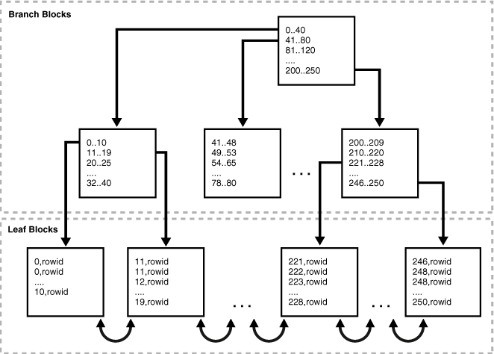

Branch Blocks and Leaf Blocks
A B-tree index has two types of blocks: branch blocks for searching and leaf blocks that store values. The upper-level branch blocks of a B-tree index contain index data that points to lower-level index blocks. The root branch block has an entry 0-40, which points to the leftmost block in the next branch level. This branch block contains entries such as 0-10 and 11-19. Each of these entries points to a leaf block that contains key values that fall in the range.
Branch blocks store the minimum key prefix needed to make a branching decision between two keys. This technique enables the database to fit as much data as possible on each branch block. The branch blocks contain a pointer to the child block containing the key. The number of keys and pointers is limited by the block size.
The leaf blocks contain every indexed data value and a corresponding rowid used to locate the actual row. Each entry is sorted by (key, rowid). Within a leaf block, a key and rowid is linked to its left and right sibling entries.

Types of Index Scans
In an index scan, the database retrieves a row by traversing the index, using the indexed column values specified by the statement.

1.Full Index Scan
In a full index scan, the database reads the entire index in order. A full index scan is available if a predicate (WHERE clause) in the SQL statement references a column in the index, and in some circumstances when no predicate is specified. A full scan can eliminate sorting because the data is ordered by index key.
Example: SELECT department_id From employees where department_id is not null order by department_id;
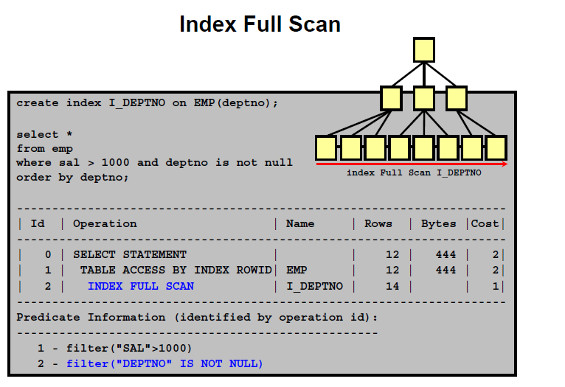

2.Index Range Scan
An index range scan is an ordered scan of an index that has the following characteristics:
- One or more leading columns of an index are specified in conditions. A condition specifies a combination of one or more expressions and logical (Boolean) operators and returns a value of TRUE, FALSE, or UNKNOWN.
- 0, 1, or more values are possible for an index key.
The database commonly uses an index range scan to access selective data. The selectivity is the percentage of rows in the table that the query selects, with 0 meaning no rows and 1 meaning all rows. Selectivity is tied to a query predicate, such as WHERE last_name LIKE 'A%', or a combination of predicates.
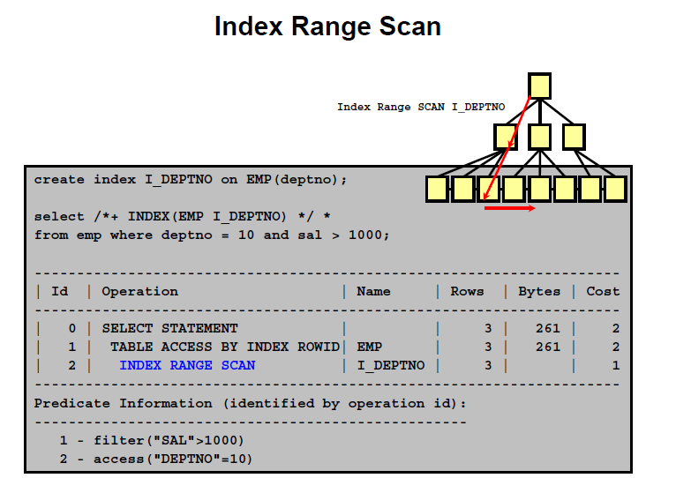
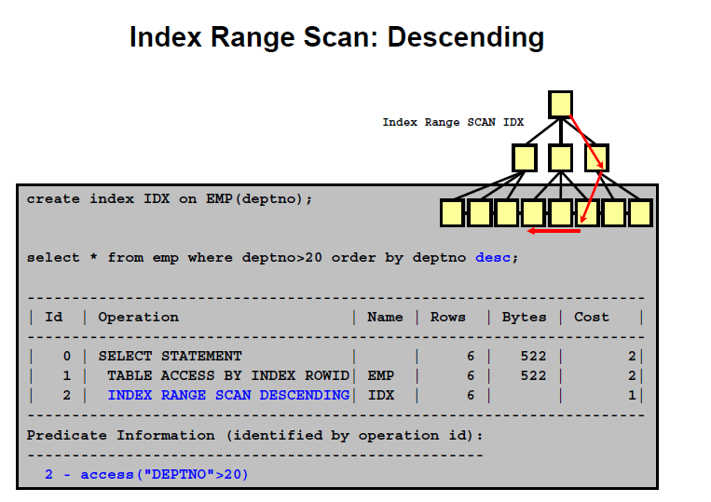
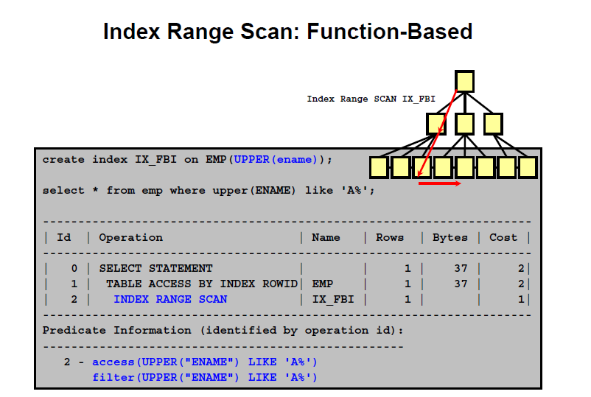

3.Index Unique Scan
In contrast to an index range scan, an index unique scan must have either 0 or 1 rowid associated with an index key. The database performs a unique scan when a predicate references all of the columns in a UNIQUE index key using an equality operator. An index unique scan stops processing as soon as it finds the first record because no second record is possible.
As an illustration, suppose that a user runs the following query:
SELECT *
FROM employees
WHERE employee_id = 200;
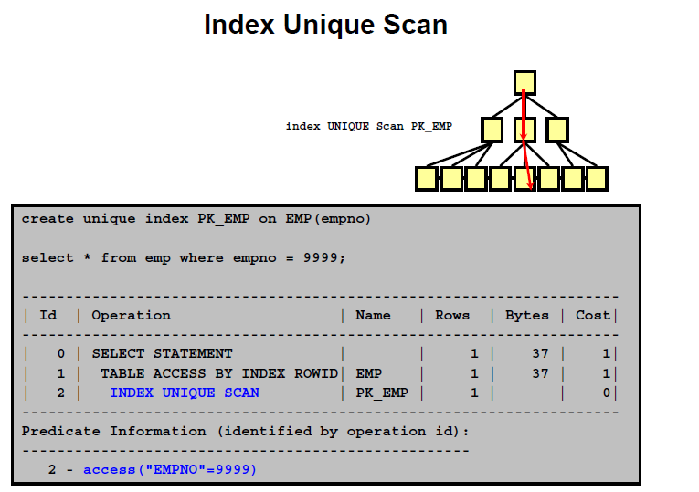

4.Index Skip Scan
An index skip scan uses logical subindexes of a composite index. The database "skips" through a single index as if it were searching separate indexes. Skip scanning is beneficial if there are few distinct values in the leading column of a composite index and many distinct values in the nonleading key of the index.
The database may choose an index skip scan when the leading column of the composite index is not specified in a query predicate.
